[
A
PROJECT REPORT
ON
“Salon Management System”

Submitted By
Miss. Dhumal Prajkta Bharat
Guided By
Ms. Gite D.P. & Mrs. Khambekar R.S.
In partial fulfilment of the award of the degree
of
M.Sc. (Computer Science)
of
Sangamner Nagarpalika Arts, D.J.Malpani Commerce & B.N Sarda Science College(Autonomous), Sangamner
(Affiliated to Savitribai Phule Pune University)

DURING ACADEMIC YEAR

2023-2024

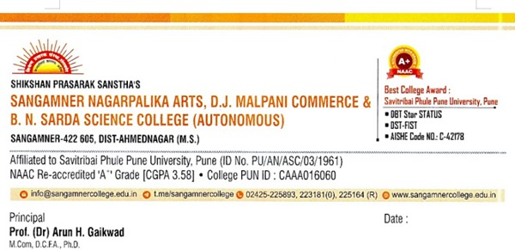

CERTIFICATE

This is to certify that, Miss Dhumal Prajkta Bharat has completed the project on Salon Management System as a partial fulfilment of M.Sc. (Computer Science) laid down by the autonomous college affiliated to Savitribai Phule Pune University, satisfactorily during the academic Year 2023-2024

Project Guide Head of the Department

Internal Examiner
External Examiner

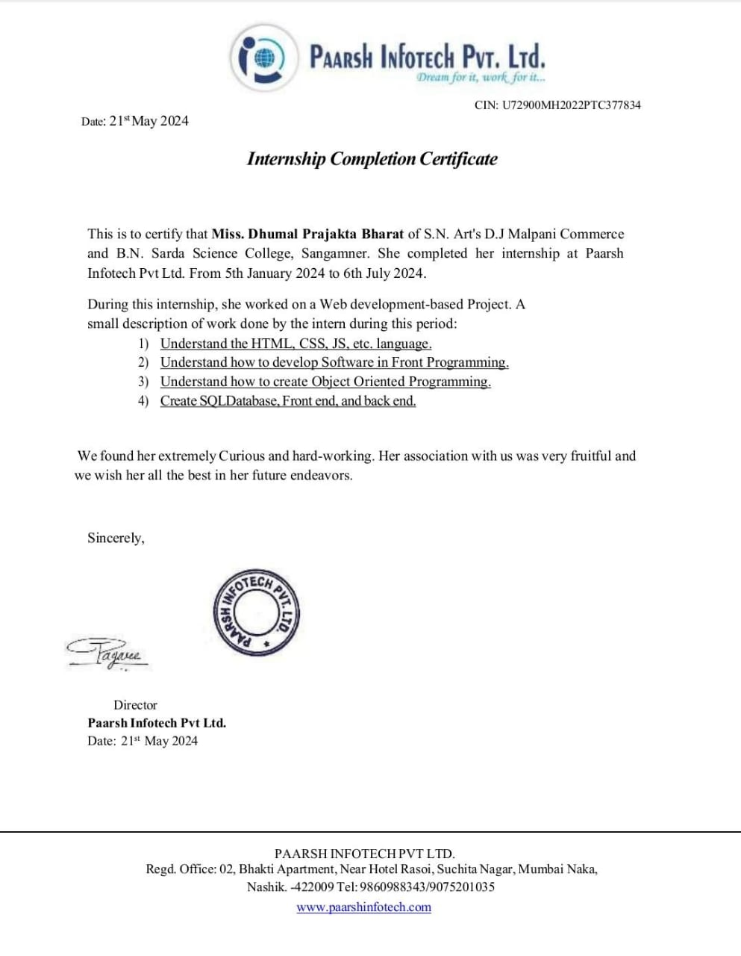

INDEX

Sr. No. | Title
1. | Acknowledgement.
2. | Problem Statement
3. | Existing system and need for new system
4. | Scope of the work
5. | Feasibility Study:  - Operational Feasibility  - Technical Feasibility  - Economical Feasibility
6. | Requirement Analysis
7. | E-R Diagram
8. | Data Dictionary
9. | UML Diagrams:  - Class diagram  - Object diagram  - Use case diagram  - Activity diagram  - Sequence diagram  - Deployment diagram
10. | User Interface Design  - Input Output Screen  - Reports
11. | Testing
12. | Limitations and proposed enhancement
13. | Bibliography & References

ACKNOWLEDGEMENT
A few words of gratitude to be inserted with project “Salon Management System”. It is our earnest duty to express our thanks to all those who contributed directly or indirectly to our project.
Firstly, we would like to thank Sangamner Nagarpalika Arts, D. J. Malpani Commerce & B. N. Sarda Science College (Autonomous), Sangamner and Department of Computer Science for giving us an opportunity. Thanks to Dr.Laddha R. S. Vice Principal, Head of Department for his encouragement and valuable guidance.
We would like to thank Miss Gite D.P., Mrs. Khambekar R.S. who initiated us to complete this project and guided us timely. It is our privilege to express our gratitude to all staff members & non-Teaching Staff members for their excellent suggestions and active co-ordination.
And finally, we would like to thank all our friends for their support and the timely help.

Yours Sincerely,
Miss. Dhumal Prajkta Bharat
M.Sc.-II(Computer Science)

Introduction

Today is the era of digital technology and the development of technology. The rise of the internet gives a boost in the digital field and India is also accepting it and runs many movements like digital India, UPI money transfer, and many more. The growth of internet users is increasing day by day and we are well aware of the advantage of the internet. At present, many people run their businesses without any physical setup of their business like digital marketing agency, digital marketing, and many more . On the other hand, the grooming and beauty business are experiencing growth in the coming year. A salon is an establishment dealing with cosmetic treatments for men and women. Other variations of this type of business include hair salons and spas.
Using this platform user can view all the salons which are partner with our salon booking system and also view their services. Like Zomato.com serve a similar need in the restaurant industry, but our system bring clients and salon together online. When customers search the salon then the system will show all the available salons on their locations and if by chance the time you have searched is not available then it will also show the next vacant slots on our system which is registered with our platform on that location. It will be useful for customers because now they have their bookings with the slots available. It will also remove all the paperwork as the owner will have access to all the customers' details and their records to serve them better. Online Payments to promote cashless transactions as it is more secure and trustworthy from both sides. In this project, MySQL and PHP are used to back the interface with strong database functionality and for Frontend HTML, CSS and JavaScript are used.
This project will target the major web browser like Google Chrome, Firefox, and Safari as the initial platform for our version. As beauty and fashion become a great trend disregarding the age limit and gender. All the Salon Owners are relying on their Customers; who visit Salons to fulfill their own beauty needs.

Problem Statement

Visiting a salon or spa without a prior appointment can keep you waiting in a queue and will take a lot of your precious time. To solve this we have developed an advanced online salon and spa booking system, that can help the user to book an appointment in their favorite salon or spa. The user can easily access the system by registering themselves on the website. The system will provide information on nearby salons/spas and their services.
The user can view the salons ‘facility, services and hair stylist’ reviews and based on that they can choose the best salon with the beautician or hair stylists suited for them and book an appointment as per their desired time and date. The users can also purchase various beauty-related products online. The users can also purchase various beauty-related products online. The system will also allow the users to drop their feedback as well.

Objective:
- Eliminate the paper based work use at the Salon premise such as, usage of
diaries to note down appointment details, writing manual invoices for the
Payments done by the Customers etc.
- Eliminate the data redundancy; keeping appointment details at several places
(Diary, mobile etc.) by several people (Owner, Employees, Customers etc.).
- Abolish the wastage of time, resources, efforts and money of the Employer,
Employees and Customers (Stakeholders).
- Improve the efficient and effectiveness of the Salon management activities,
Services and processes like maintaining Customers, Appointments and Payments etc.
- Ease the management and decision making while improving Salons’ good name.
- Improve the Client satisfaction and Employee satisfaction.
- Enhance the Stakeholder integration.

Existing System and Need For New System

Existing System:
The paper talks about the process of the salon booking website. There are some salons that have good quality web applications to hold their appointment processes. But when considering all the salons in India, there are a number of salons that hold their services manually.
Every other salon is conducting their appointment manually which makes the process very hectic and inefficient. Moreover, peoples are increasing day by day. So, there is a need for a reliable solution to handle this situation.

Need For New System:
Getting a good grooming session, you definitely require a salon. Getting a haircut, waxing, manicures, pedicures are some of the grooming treatments which definitely need expert touches, and we generally cannot do them without training. This is again why salons are so important..
By implementing efficient staff management practices, a salon can ensure that it has a skilled and reliable team of employees who are capable of delivering high-quality services to customers. This can help to enhance customer satisfaction, boost customer loyalty, and increase revenue

Scope Of Work

- Providing the facility to registering Salon staff and maintaining their details.
- Providing the facility to registering regular Customers and maintaining their
details.
- Facilitate appointment handling.
- View appointments leaves and holidays through an event calendar.
- Handling Salon Services along with their respective prices, hours etc.
- Providing Customer Payment handling option.
- Generating invoices through the system.
- Generating reports to support the higher managerial decisions.
- Maintaining an information center (dashboard).
- Reminder generating facility through emails.

Feasibility Study

1)Technical Feasibility:
This developed system has technically feasible because the technology needed for the proposed system is available.
The proposed system is integrated within the organization is easy.
Technically this system is very much safe and sound.
The system does not need extra hardware to run the given project.

2)Economical Feasibility:
The proposed system is economically feasible because the cost of the project is not more at organization level.
If the organization has to be identified the financial benefits and cost associated with the development project is big difference then the project will more feasible at organization level.
The benefits are high and cost is less i.e., economically feasible.

3) Operational Feasibility:
As system is very much user friendly so user of the system can easily work and interact with the system i.e. no need of expert person to handle the system.

Requirement Analysis:
Software and Hardware Requirement
Hardware Requirement:
- HDD: 512GB
- RAM: 8GB
- Mouse
- Keyboard
- Monitor
Software Requirements
Front End Tools:
- HTML
- CSS
- JavaScript

- HTML: The HTML is used to create and save web document.
- CSS: Cascading Style Sheet create attractive Layout.
- JavaScript: JavaScript is programming language, commonly use with web browsers.
Back End:
- PHP
Database:
MySQL: Used for managing and maintaining relational databases, SQL is the go-to language when it comes to backend data. Essentially, it's the language that communicates with the data held in the server.
Operating System:
Windows 10 and above
Web Browser:
Google Chrome, Internet Explorer
ER- Diagram:
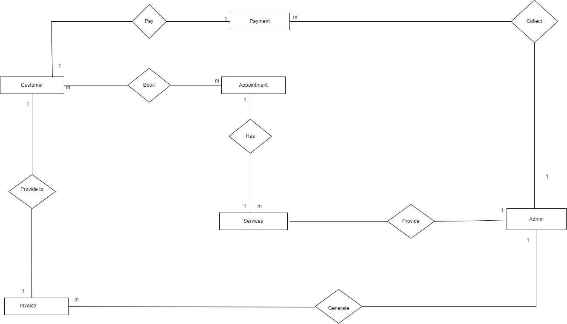

Data Dictonary
Admin Table:
Fields | Data Type | Constraint | Default
Id | Int(10) | Primary Key | None
Admin_ name | Char(50) | Not Null | None
User_ name | Char(50) | Not Null | None
Mobile_ number | int(10) | Not Null | None
Email | Varchar(200) | Not Null | None
Password | Varchar(200) | Not Null | None
AdminRegdate | Timestamp | Not Null | Current_timestamp()

Appointment Table:
Fields | Data Type | Constraint | Default
Id | Int(10) | Primary Key | None
Apt_number | Varchar(80) | Not Null | None
Name | Varchar(120) | Not Null | None
Email | Varchar(120) | Not Null | None
Phone_number | Int(11) | Not Null | None
Apt date | Varchar(120) | Not Null | None
Apt time | Varchar(120) | Not Null | None
Services | Varchar(120) | Not Null | None
Apply date | Timestamp | Not Null | Current_timestamp()
Remark | Varchar(200) | Not Null | None
Status | Varchar(50) | Not Null | None
Remark date | Timrstamp | Not Null | None

Invoice Table:
Field | Data Type | Constraint | Default
Id | Int(11) | Primary Key | None
User_id | Int(11) | Not Null | None
Service_id | Int(11) | Not Null | None
Billing_id | Int(11) | Not Null | None
Posting date | Timestamp | Not Null | Current_timestamp()

Customer Table:
Fiels | Data Type | Constraint | Default
Id | Int(10) | Primary Key | None
Name | Varchar(120) | Not Null | None
Email | Varchar(200) | Not Null | None
Mobile number | Int(11) | Not Null | None
Gender | Varchar(25) | Not Null | None
Details | Text | Not Null | None
Creation date | Timestamp | Not Null | Current_timestamp()
Updation date | Timestamp | Not Null | None

Page Table:
Field | Data Type | Constraint | Default
Id | Int(10) | Not Null | None
Page_type | Varchar(200) | Not Null | None
Page _title | Text | Not Null | None
Page_description | Text | Not Null | None
Email | Varchar(200) | Not Null | None
Mobile_number | Varchar(200) | Not Null | None
Updation_date | Date | Not Null | None
Time | Varchar(200) | Not Null | None

Service Table:
Field | Data Type | Constraint | Default
Id | Int(10) | Primary Key | None
Service_name | Varchar(200) | Not Null | None
Description | Text | Not Null | None
Cost | Int(10) | Not Null | None
Creation_date | Timestamp | Not Null | Current_timestamp()

Subscriber Table:
Field | Data Type | Constraint | Default
Id | Int(10) | Not Null | None
Email | Varchar(100) | Not Null | None
Date_of_subscribe | Timestamp | Not Null | Current_timestamp()

UML Diagram
Class Diagram:
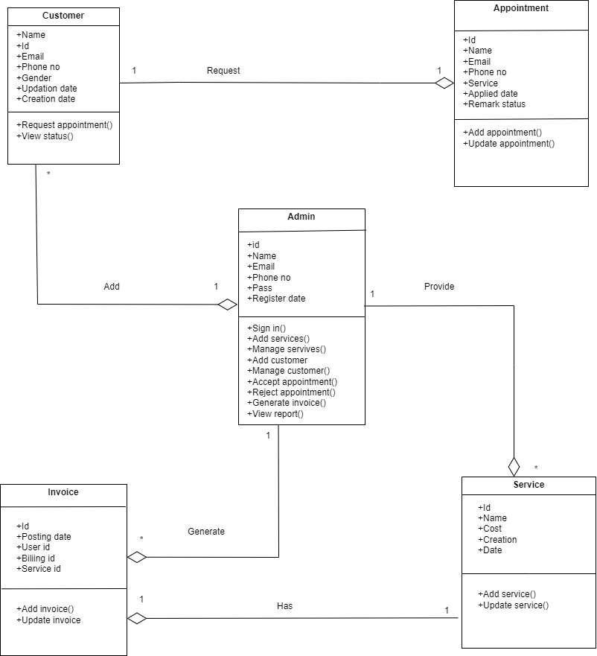

Object Diagram:

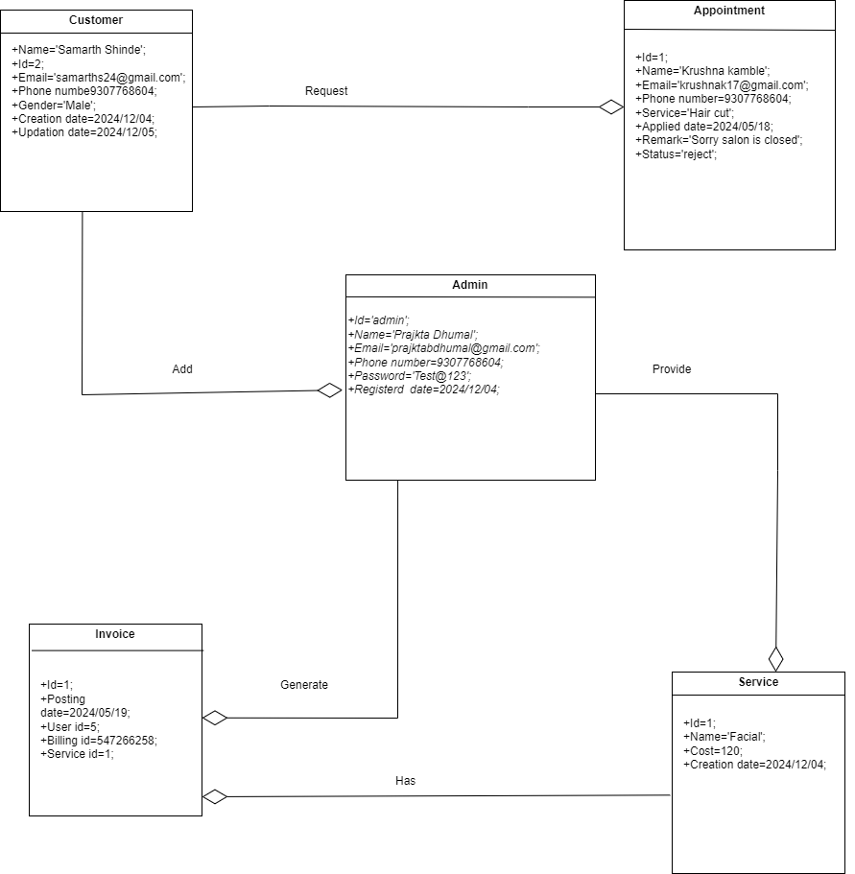

Sequence Diagram:
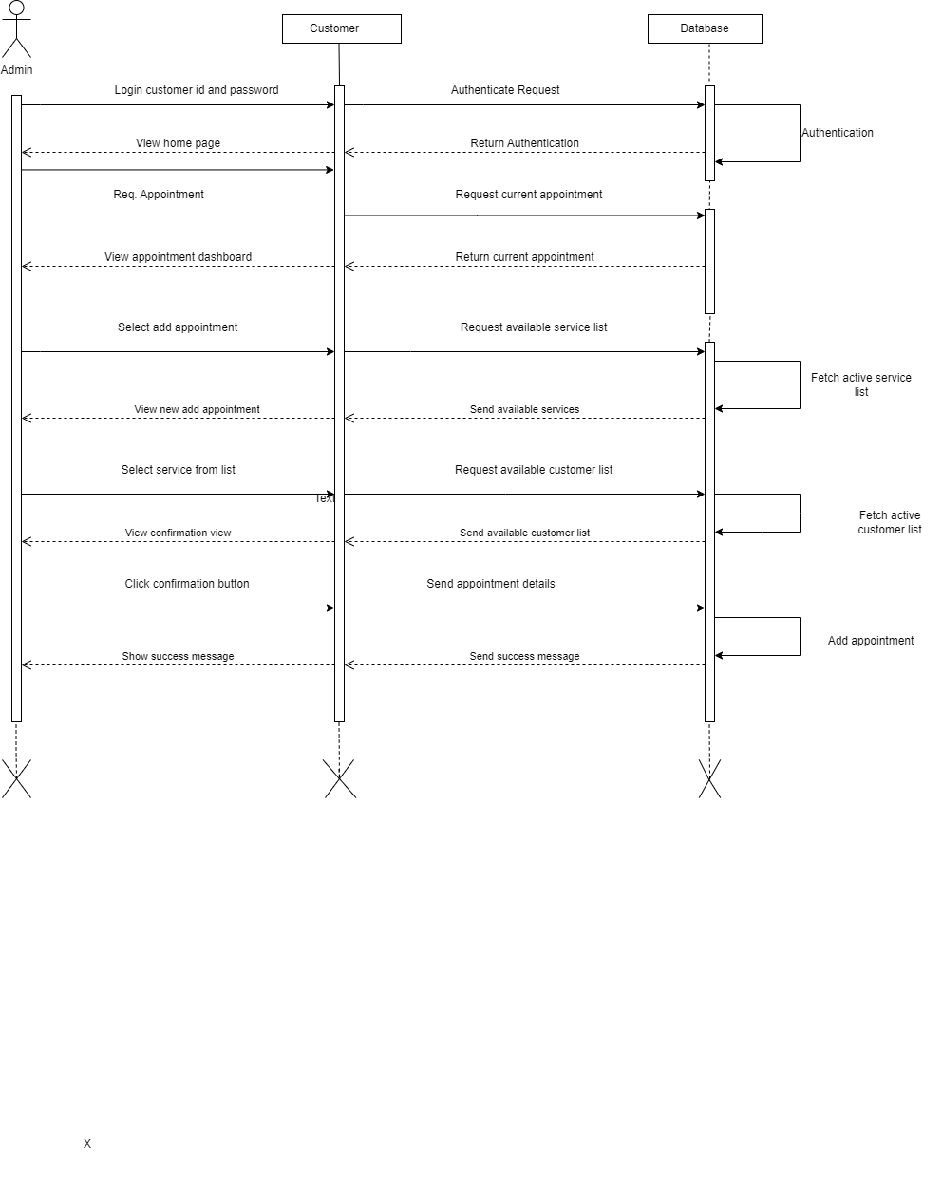
Use-Case Diagram:

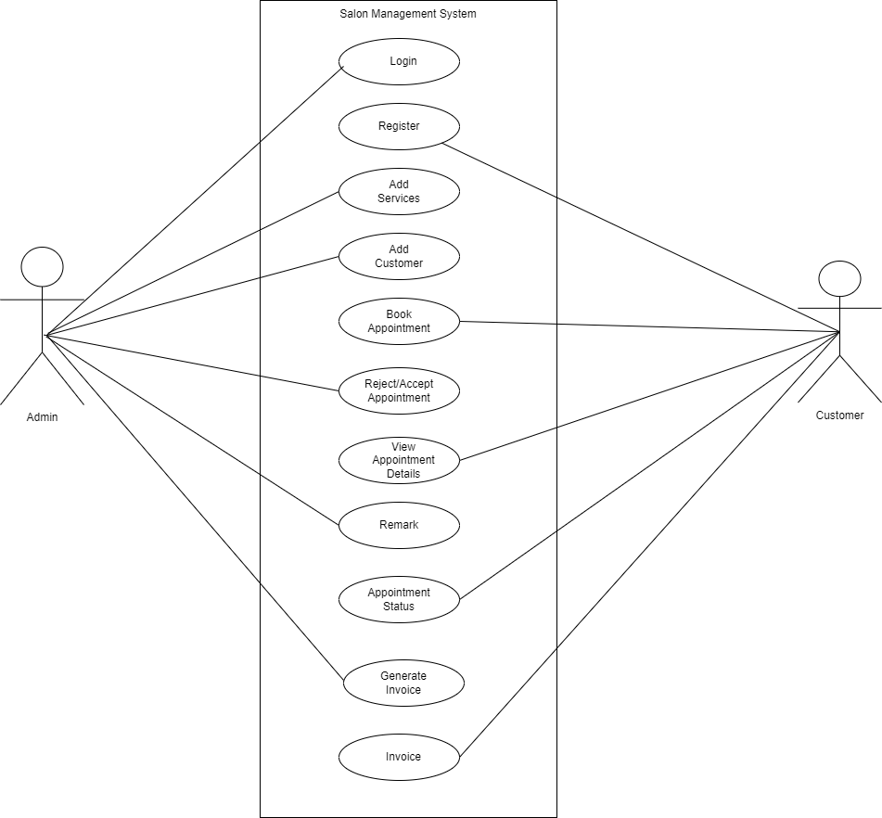

Activity Diagram:

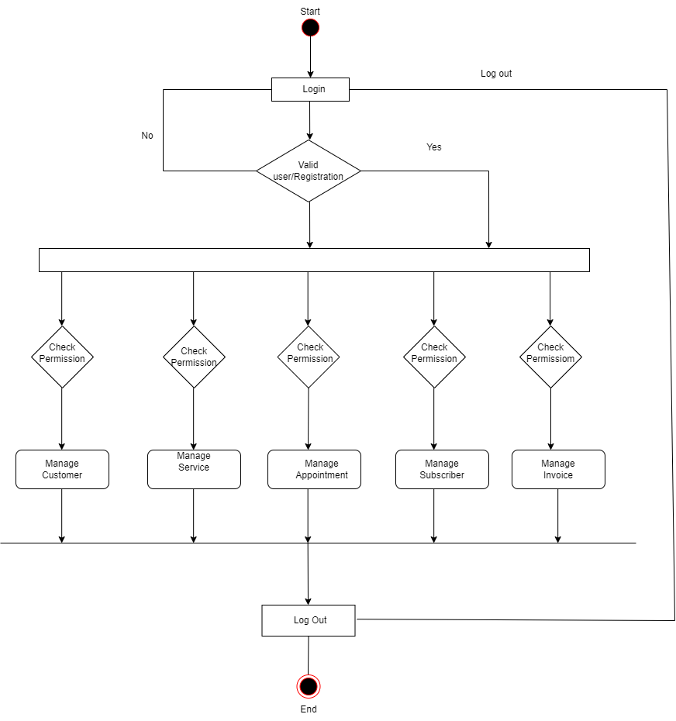

Deployment Diagram:

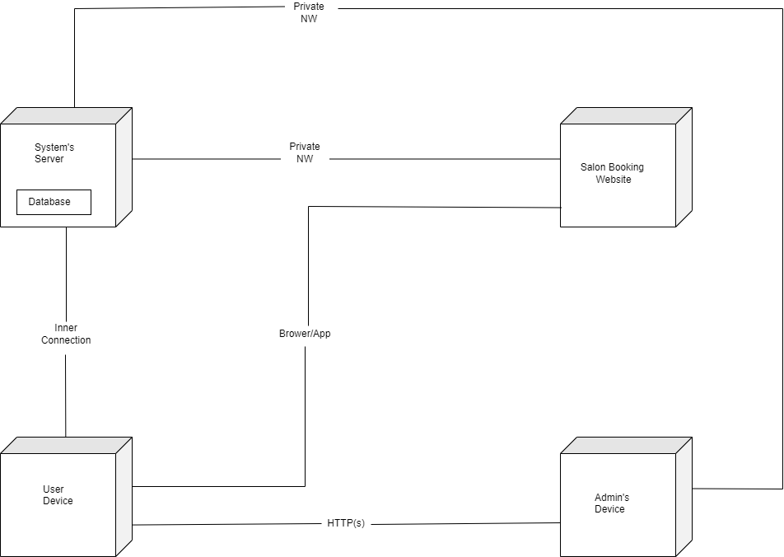

Input/Output Screen
Home:
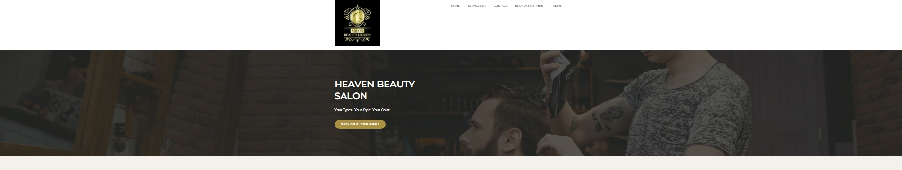


Login:
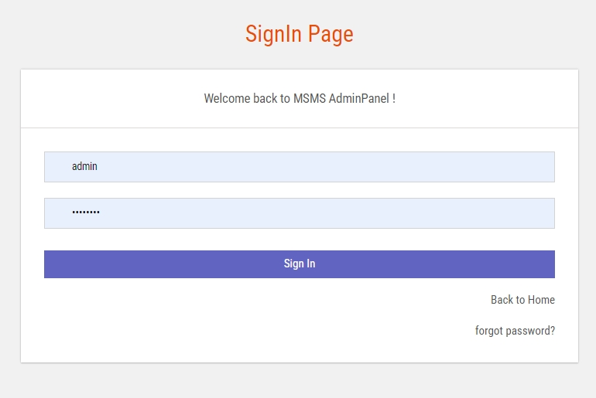
Dashboard:

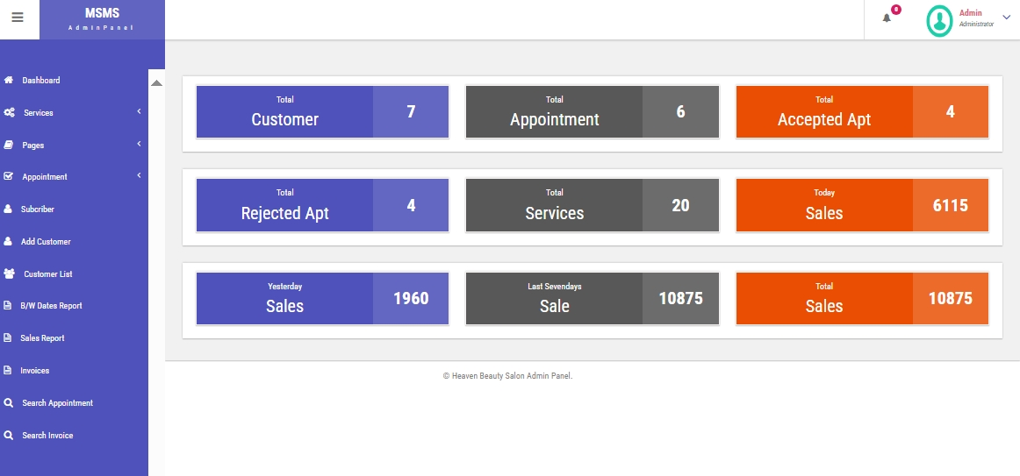
Add Services:
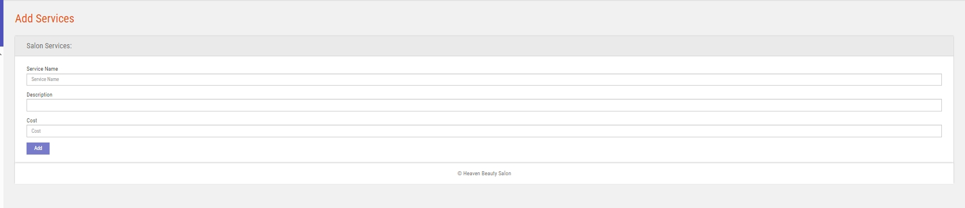

Services:
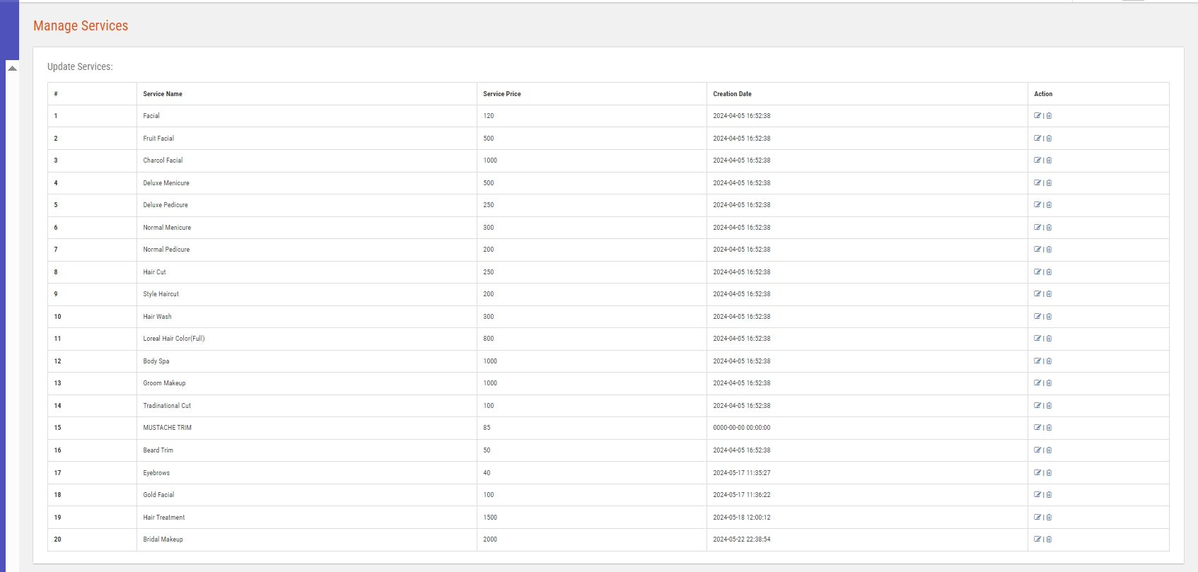
About Us:
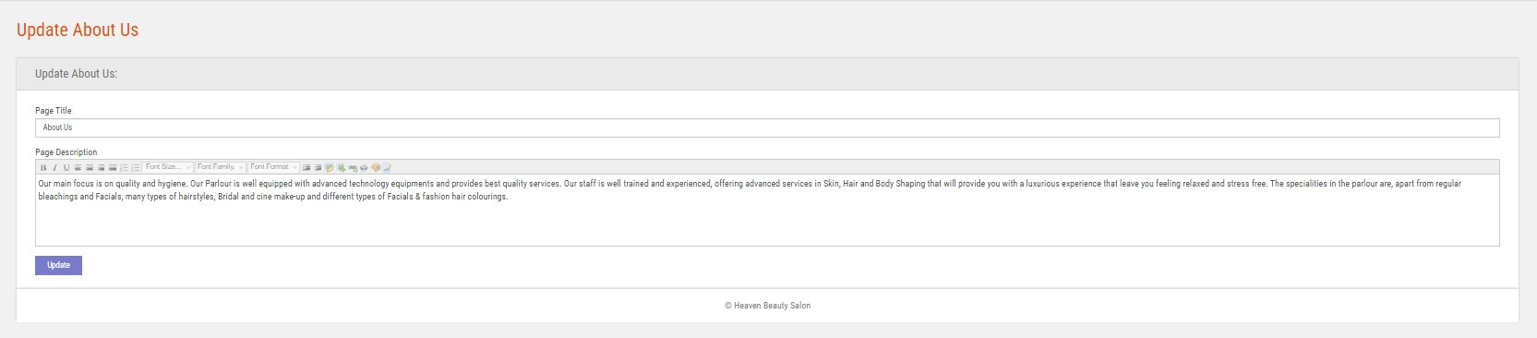

Contact Us:
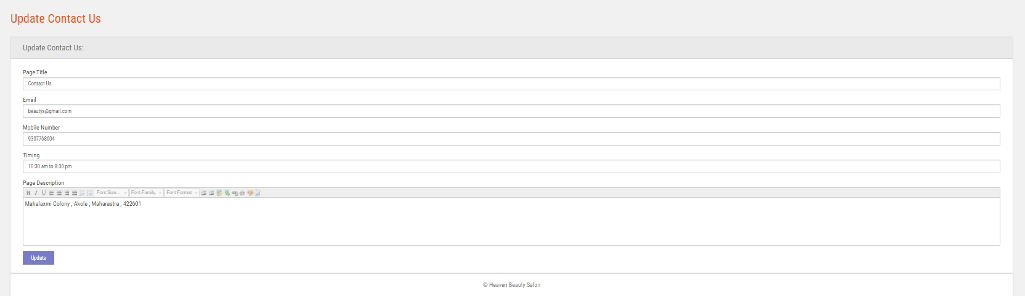
Appointment:
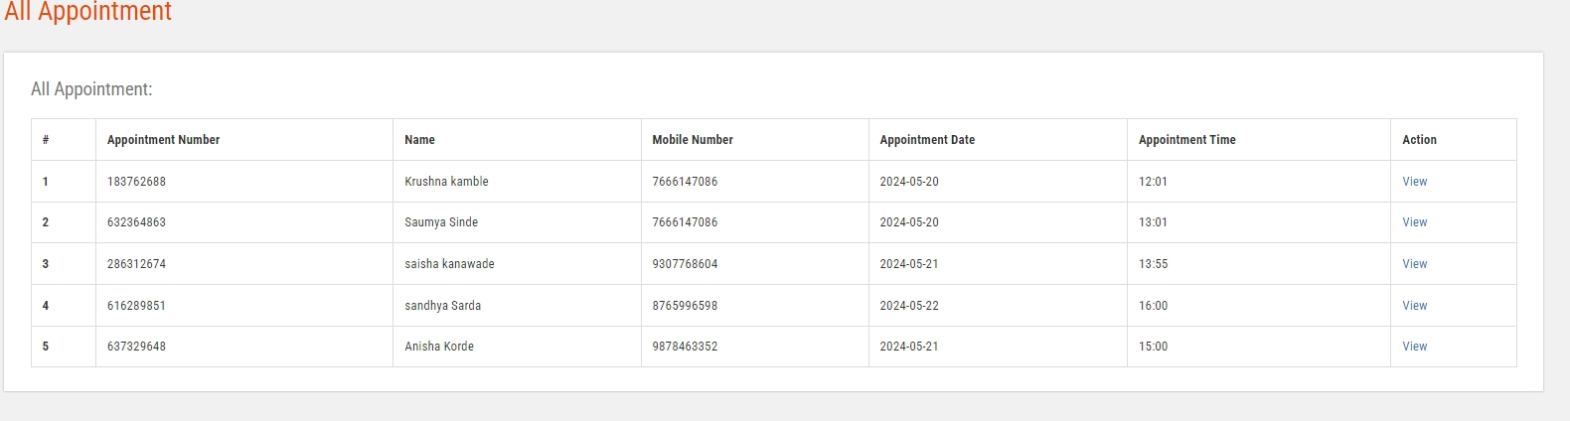

Accepted Appointment:

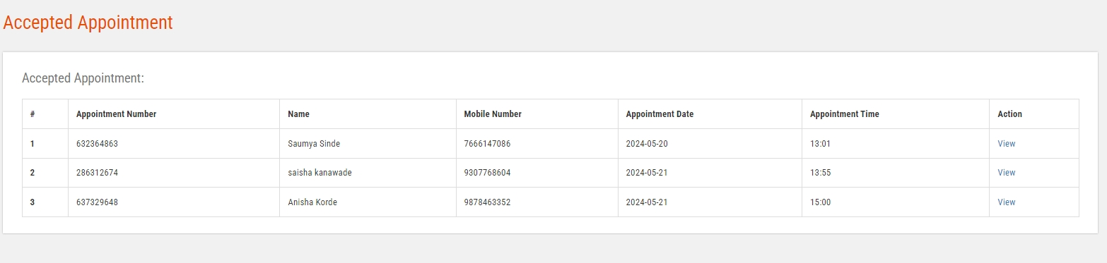

Rejeceted Appointment:

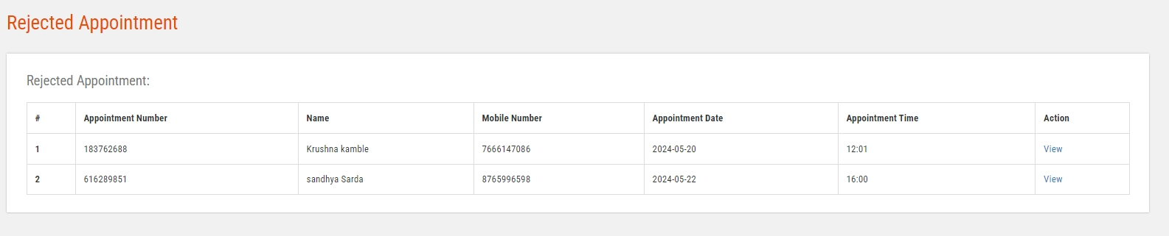

Subscriber:

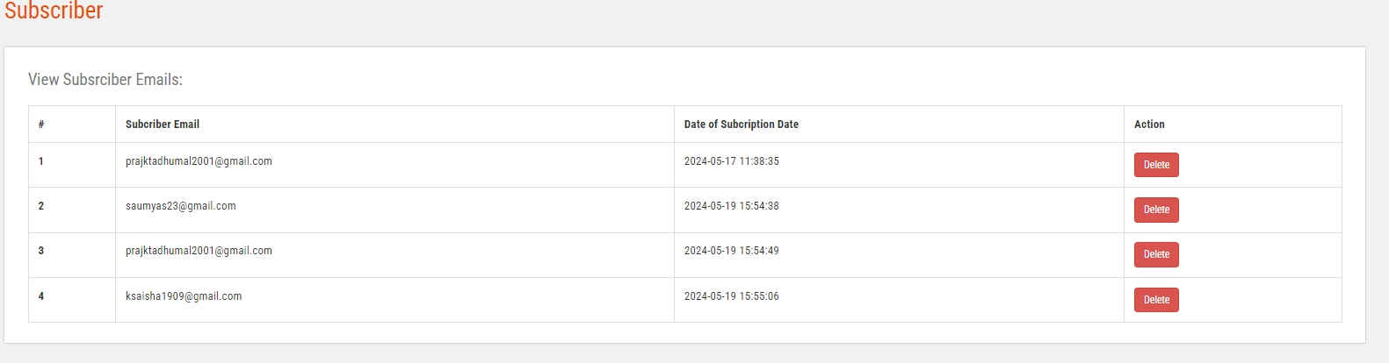

Add Customer:
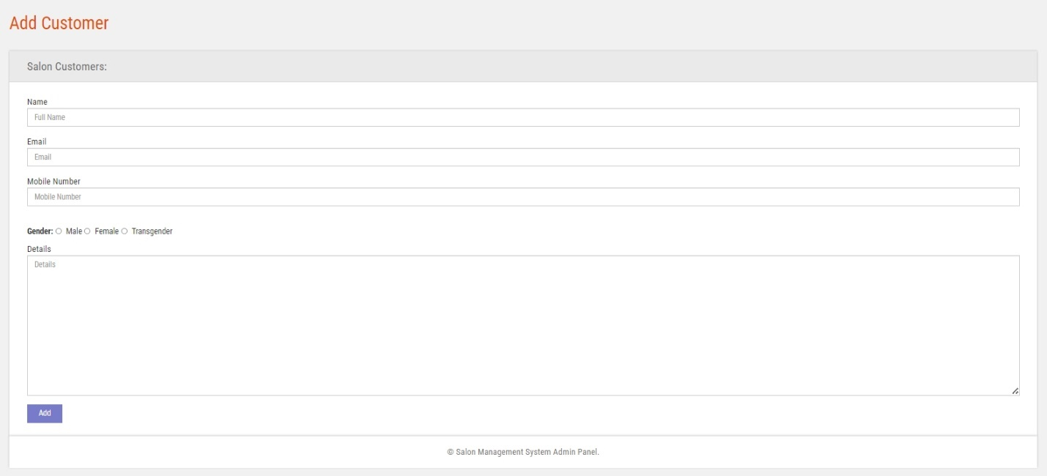

Customers List:
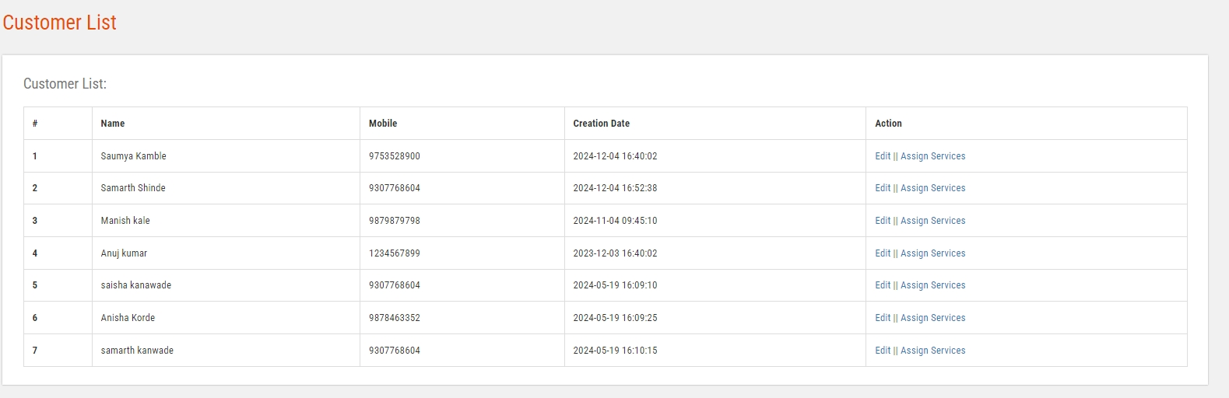

Between Dates Report:
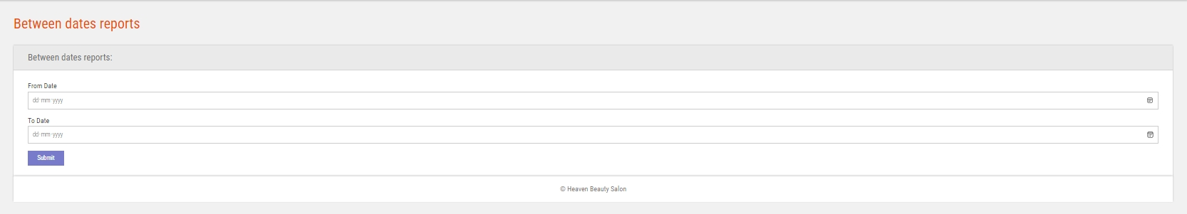

Sales Report:
Invoice:
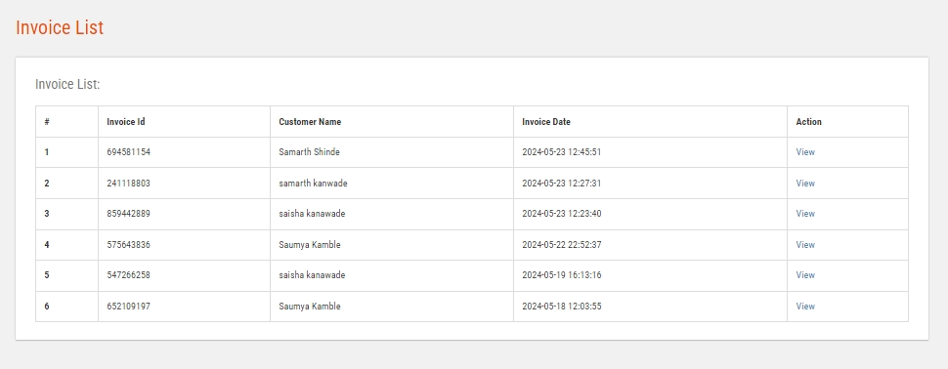
Invoice Details:
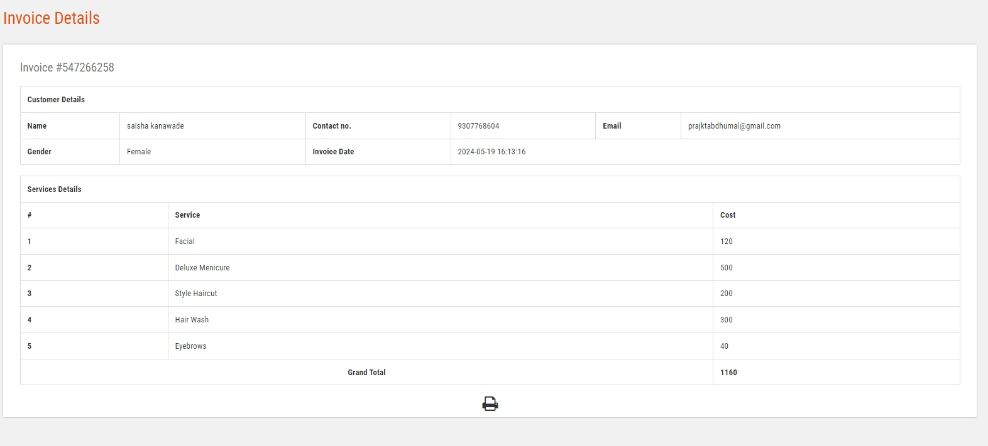

Search Appointment:

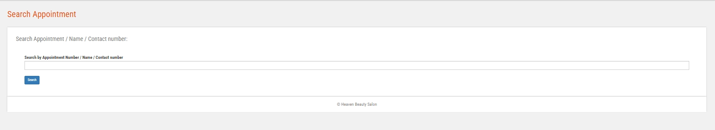

Search Invoice:
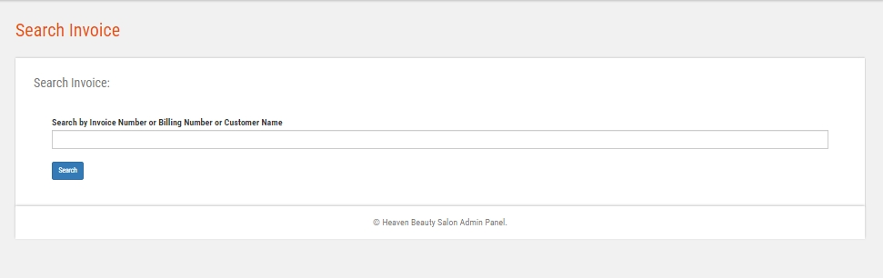

Testing
Login:
Test Case ID | Test Scenario | Test Case | Pre-Condition | Test Steps | Test Data | Expected Result | Actual Result | Status  Pass/Fail
TC_Login_1 | Verify Login | Enter Valid username and valid password | Need a valid username and password to do login | 1. Enter username  2. Enter Password  3. Click Login | Valid username  Valid password | Successful login, Main screen of application should displayed | Successful login, Main screen of application displayed | Pass
TC_Login_2 | Verify Login | Enter Valid username and invalid password | Need a valid username and password to do login | 1. Enter username  2. Enter Password  3. Click Login | Valid username  Invalid Password | No Matched Username/ Password | No Matched Username/ Password | Pass
TC_Login_3 | Verify Login | Invalid username and valid password | Need a valid username and password to do login | 1. Enter username  2. Enter Password  3. Click Login | Invalid username  Valid Password | No Matched Username/ Password | No Matched Username/ Password | Pass
TC_Login_4 | Verify Login | Enter Invalid username and invalid password | Need a valid username and password to do login | 1. Enter username  2. Enter Password  3. Click Login | Invalid username  Invalid Password | No Matched Username/ Password | No Matched Username/ Password | Pass

Registration:

Test Case ID | Test Scenario | Test Case | Pre-Condition | Test Steps | Test Data | Expected Result | Actual Result | Status  Pass/Fail
TC_CREG_1 | Verify User Registration Detail | Enter valid name, email, new password | Need valid Data to be entered | 1. Enter name  2. Enter email  3. Enter Password  4. Click Sign up | Valid name, valid email, valid password | Successful, User Added Successfully | Successful, User Added Successfully | Pass
TC_CREG_2 | Verify Staff Registration Detail | Enter name, already registered email, new password | Need Data to be entered | 1. Enter name  2. Enter Email  3. Enter Password  4. Click Sign up | Valid name, already registered email, valid password | Email ID Already Registered | Email ID Already Registered | Pass
TC_CREG_3 | Verify Staff Registration Detail | Entering Nothing, Required Fields are blank | - | Click Sign up | Nothing to enter Required fields are blank | Fill required field | Fill required field | Pass

Add Services:

Test Case ID | Test Scenario | Test Case | Pre-Condition | Test Steps | Test Data | Expected Result | Actual Result | Status  Pass/Fail
TC_Service_1 | Verify Service Detail | Enter Valid and correct data | Need valid text and number Data to be entered | 1. Enter Valid Data in appropriate fields  2. Click Submit | Valid Text and Number Data | Successful, Service Added Successfully | Successful, Service Added Successfully | Pass
TC_Service_2 | Verify Service Detail | Enter invalid and incorrect data | Need text and number Data to be entered | Enter invalid Data in fields | Invalid Text and Number Data | Enter Valid Data | Enter Valid Data | Pass
TC_ Service _3 | Verify Service Detail | Entering Nothing, Required Fields are blank | - | Click Submit | Nothing to enter Required fields are blank | Fill required field | Fill required field | Pass

Limitations and Proposed Enhancement

Limitations:
  - Cannot accept credit card.
  - Need good internet Connection
  - Customer needs their own email or phone number for booking appointment

Proposed Enhancement:
- Any Customer registers for the book appointment.
- Reducing cost by automating system and minimizing errors. Compared to the existing system the proposed system will provide a better working environment in which they will be ease of work and the effort required will be comparatively less.
- Also the time required generating a report or for doing any other work will be comparatively very less. Labor work is comparatively less as the time required generating a report or for doing any other work will be comparatively less.
- To know exactly about particular organization growth.
- Providing security to system is important.
- The system has facility to maintain data of customer and total sales in proper.
- Centralized storage of data helps to retrieve data
- Improve appointment booking using mobile app.

.
.

Conclusion and Recommendation Future Scope

Conclusion:

- This system will help saloons to pitch their business underneath their space to expand their everyday business.
- This project also helps local vendors to show their presence globally on the internet and serve their customers with their art.
- In the salon and beauty industry, the Online Appointment Booking System is suitable for use to reduce customer waiting time and experience a hassle-free environment.

Recommendation Future Scope:

- Create attractive separate web sites for each branches using data collect
in current version.
- Improve appointment booking using mobile app
- Enhance the features of the system

Biblography and References

Before and at the time of developing project following Reference Books and Website are refered which gear us some impotant guidline for designing and developing the project and project reports.
Reference Book:
- The complete Reference(HTML and CSS) – Thomas A.Vincent.
- Programming PHP By Rasmus Lerdorf and Kevin Tatroe, O'Reilly publication.
- PHP web services, Wrox publication.
- Mastering PHP , BPB Publication.
- Beginning PHP 5 , Wrox publication.
- PHP web services, Wrox publication.
- Mastering PHP , BPB Publication.
- PHP cookbook, O'Reilly publication.
- PHP for Beginners, SPD pub
- PHP for Beginners, SPD publication.

Website:
WWW.stackoverflow.com
WWW.getbootstrap.com
WWW.W3School.com
WWW.google.co.in
WWW.php.net
WWW.wikipedia.org

